Model Test Preparation

## Name: Om Ashish Mishra

## Registration Number: 16BCE0789

## Slot: L19+L20

# Question 3.

3. Consider the Book keeping system

a. Identify the core requirements. (5)

b. Identify the critical path of this project with a scheduling diagram you are familiar with. (15)

c. Draw the activity diagram with swim lane and various levels of dataflow diagram for the given scenario. (20)

d. Draw ER diagram to represent the database structure. (10)

# Answer:

B).

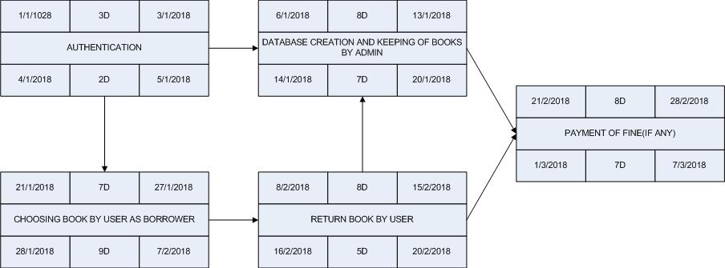



C).

Activity Daigram

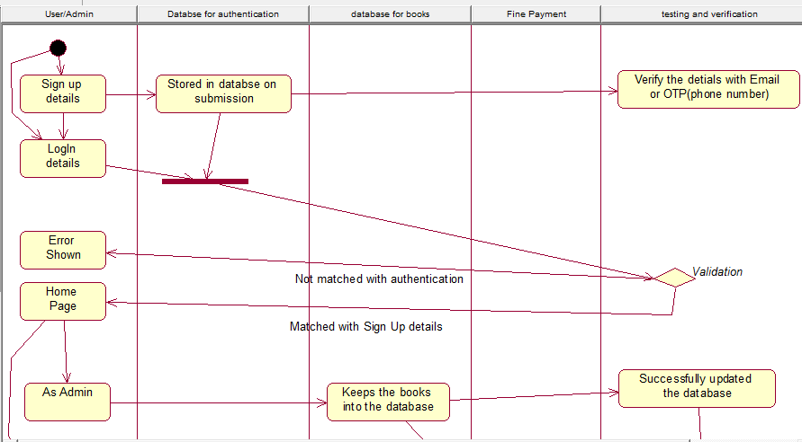

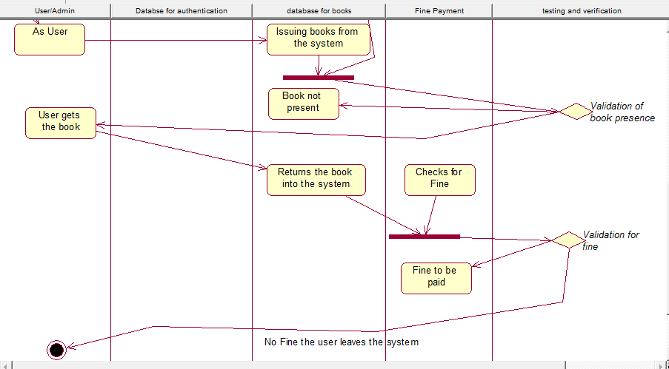

Data Flow Daigram

Data0

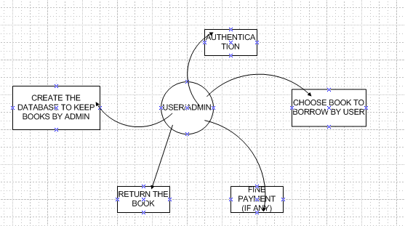

Data1

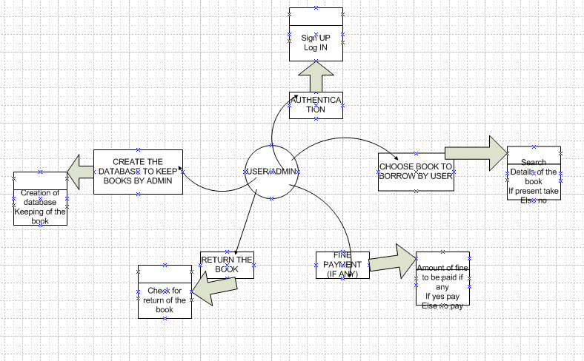

Data2

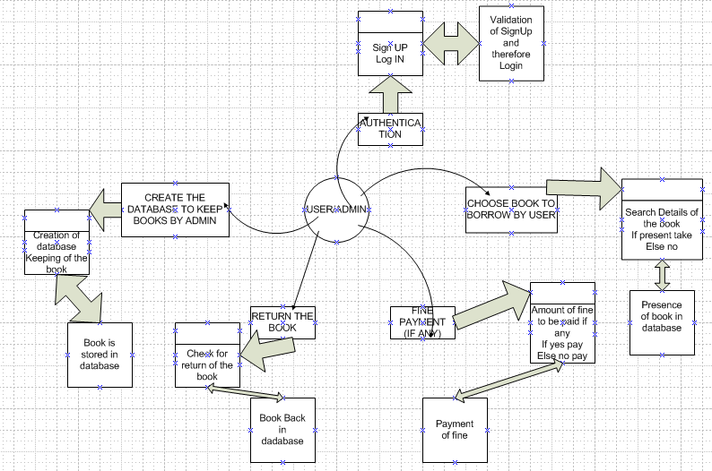

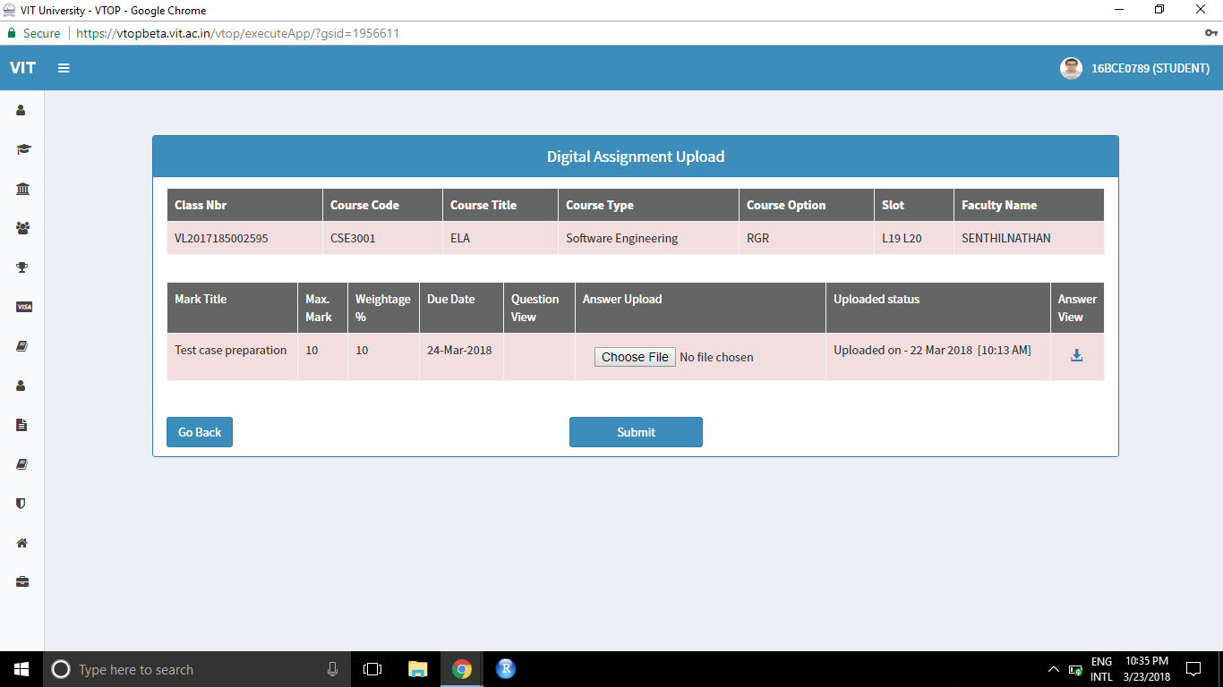



Sorry Sir on the day of examination, I by mistake uploaded in Test case preparation and therefore I correctly uploaded back into exam model.

D.)

